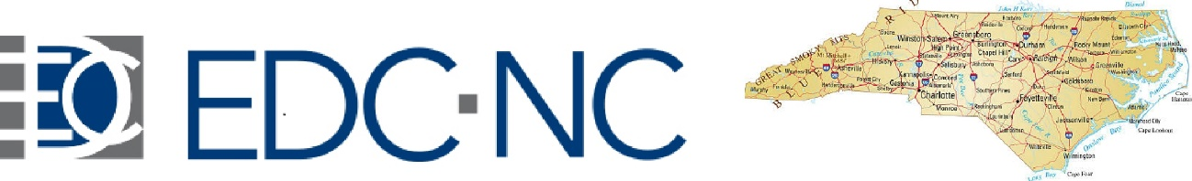

**Third Annual Scientific Meeting**

**Friday, September 30, 2022**

**8:00 a.m. to 6:00 p.m.**

**North Carolina State University**

Tally Student Union

Coastal Carolina Ballroom 3rd Floor

2610 Cates Avenue, Raleigh NC

**Keynote Speaker**

**Kelly Ferguson, NIEHS**

**Sessions**

EDCs and Diseases/Dysfunction

Two Hit Hypotheses in Endocrine Disruption

EDCs and Thyroid Cancer

Techniques in EDC Research

Early Morning Trainee Session on Plagiarism and Copyright Issues

***There will be awards for best trainee posters***

***Free Box Lunches and Reception***

**Registration is Free but Required by September 20, 2020**

**Register Here**: <https://forms.gle/4rybEEm9Y7nKWFb56>

**Meeting Program:** <https://heeds.org/edc-nc-annual-meeting/>

EDC-NC is a program of [www.HEEDS.org](http://www.HEEDS.org)

